Leung, Cristian K (Student)



AWS Lab 1-3

Purpose
The main purpose of these labs is to familiarize with the amazon cloud interface and grasp the ropes. creating
Background Information
The first lab is on AWS IAM (Identity and Access Management) which is a service that helps you control who has access to the resources and what actions they can perform. IAM is commonly used for managing employee access to AWS or cross account access between AWS accounts. To use IAM you make groups of users that share the same permissions and create policies, JSON documents of what is allowed and denied. You can also make roles which are like temporary permissions.
When AWS first launched 2006-2010, users used root account credentials for everything. This means that everyone had the same permissions and shared the same credentials. This would lead to a massive security risk if the credentials ever got leaked. To fix this AWS introduced IAM in 2011 to solve these issues and IAM roles were added later in 2012.
The next lab is on AWS VPC (Virtual Private Cloud), AWS VPC is your private network inside AWS. You control who can enter, leave, or communicate inside it. A VPC normally includes subnets smaller sections of the network, route tables that tell traffic where to go, internet gateway which allow internet access, security groups, and network ACLs which are firewall rules on the subnet level. It allows you to isolate your AWS resources, restrict traffic, and to connect AWS to networks using VPNs.
Before VPC’s, EC2 instances ran in a shared network called EC2-Classic. The problem with this was that customers had a very limited control over it and couldn’t make custom IP ranges, private subnets, or route tables and ACLs. At the start this was fine but over time businesses wanted more control over security and networking. That’s why VPC was launched in 2009. It started off with custom IP ranges, subnets, route tables, VPN’s, and greater security + network isolation. VPC continued to grow in the 2010s as AWS kept adding new features: security groups, internet gateways, network ACLs, etc. As VPC kept growing EC2-Classic gradually phased out. Now every EC2 instance runs inside a VPC.
For the final lab we are focused on AWS EC2 (Elastic Compute Cloud) which is AWS’s service for renting virtual computers in the cloud. Instead of buying physical hardware like a server you just rent a virtual one from AWS. You can run most things like websites, game servers, AI, applications, databases etc. This helps companies have more flexibility as you can easily increase or decrease processing power without over or underinvesting.
Before cloud computing was common companies had to buy physical servers. This would not only cost a lot and take a lot of time but also lead to inefficiencies due to paying for hardware that isn’t being used. In 2006 EC2 was launched to fix these problems. As years went on 2008-2012, AWS has continued to add features such as elastic Ips, availability zones, auto scaling and more.
Lab Summary:

Lab 1: Introduction to AWS IAM

Task 1: Explore the Users and Groups
- In the AWS search bar, search for IAM and open the IAM console.
- In the left navigation pane, select IAM Users. There should be 3 users similar to below:
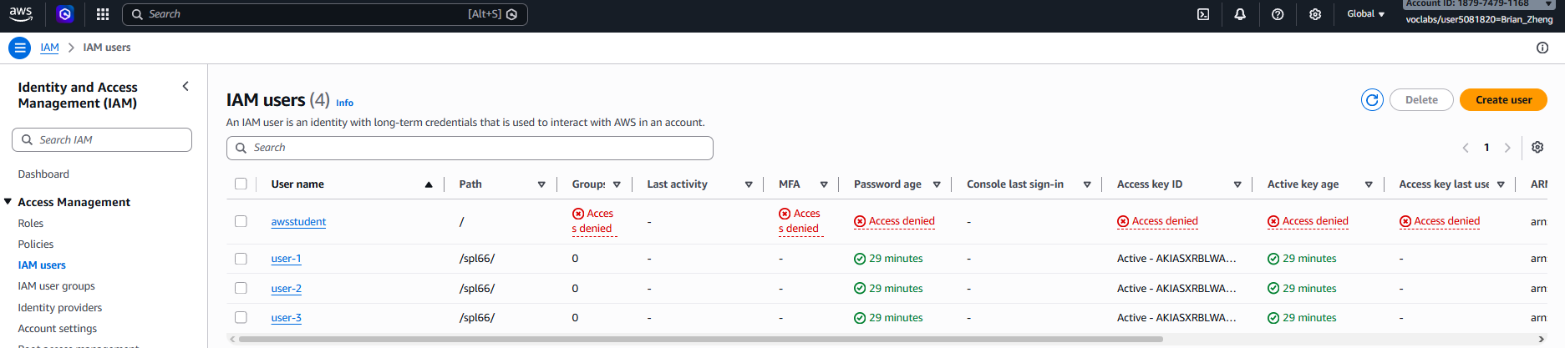
- Select user-1. On the summary page you should see:
Permissions tab: No permissions assigned.
Groups tab: Not a member of any groups.
Security credentials tab: Has a console password.
- In the left navigation pane, select User groups. The following groups should be available: EC2-Admin, EC2-Support, S3-Support
- Select EC2-Support and open the Permissions tab. Here are some things you can check out:
  - The group has the managed policy AmazonEC2ReadOnlyAccess attached.
  - This policy allows users to view EC2, Elastic Load Balancing, CloudWatch, and Auto Scaling resources, but you can’t modify them.
  - IAM policies contain:
    - Effect Allow or Deny
    - Action Permitted AWS API operations
    - Resource Resources the policy applies to
- Return to User groups, select S3-Support, and open the Permissions tab.
  - The group uses the AmazonS3ReadOnlyAccess managed policy.
  - Expand the policy to view details.
  - This policy allows users to list and retrieve Amazon S3 resources.
  - Collapse the policy when finished.
- Return to User groups, select EC2-Admin, and click on the Permissions tab.
  - This group uses an inline policy, which is attached only to this specific group.
  - Expand the policy to view details.
  - The policy allows users to describe EC2 resources and start or stop EC2 instances.
  - Collapse the policy when finished.
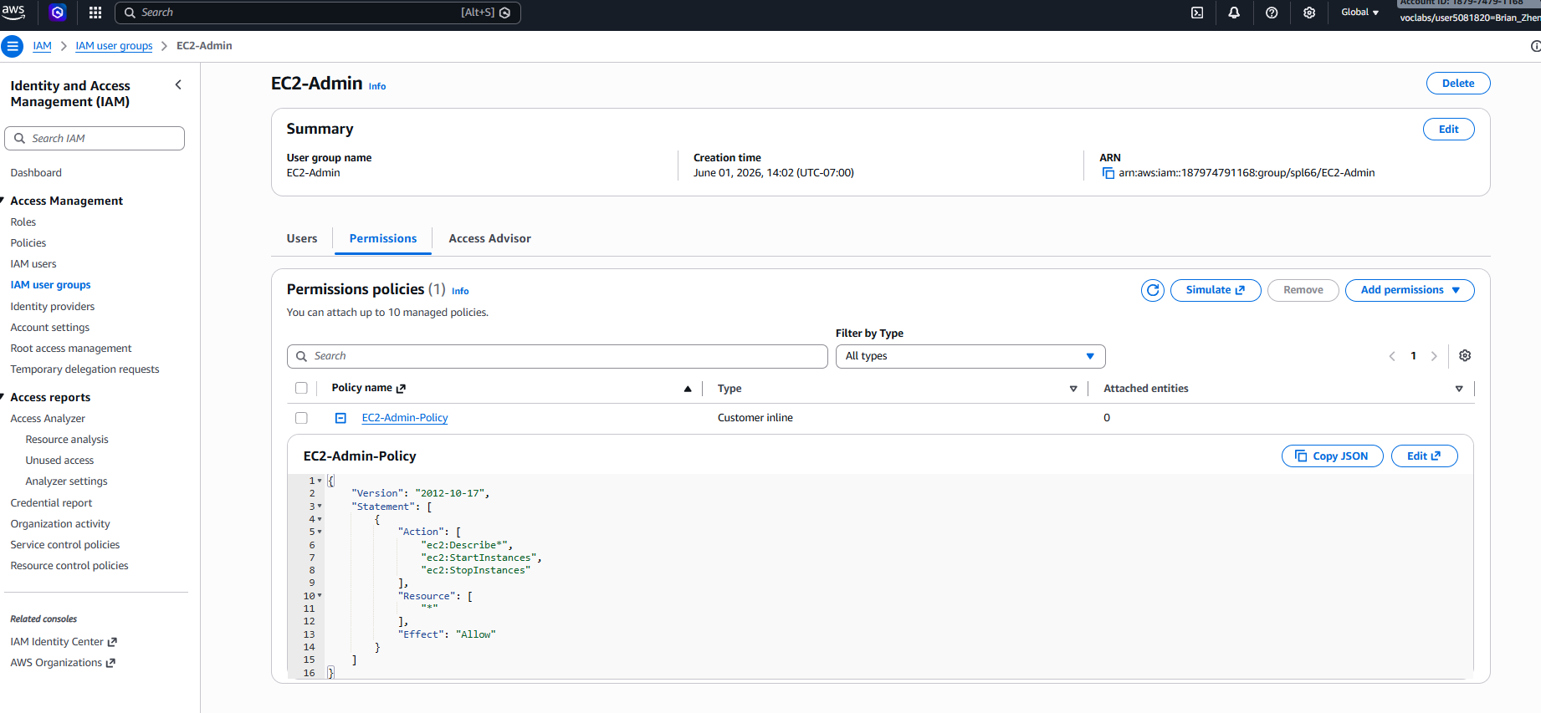

Task 2: Add Users to Groups
- In the left navigation pane, select User groups.
- Choose the S3-Support group and open the Users tab.
- Select Add users, choose user-1, and then select Add users to add the user to the group.
- Verify that user-1 now appears in the group's user list.
- Return to User groups, select EC2-Support, and open the Users tab.
- Select Add users, choose user-2, and then select Add users.
- Verify that user-2 has been added to the EC2-Support group.
- Return to User groups, select EC2-Admin, and open the Users tab.
- Select Add users, choose user-3, and then select Add users.
- Verify that user-3 has been added to the EC2-Admin group.
- Return to User groups and confirm that each group displays 1 in the Users column, it should look like the following:
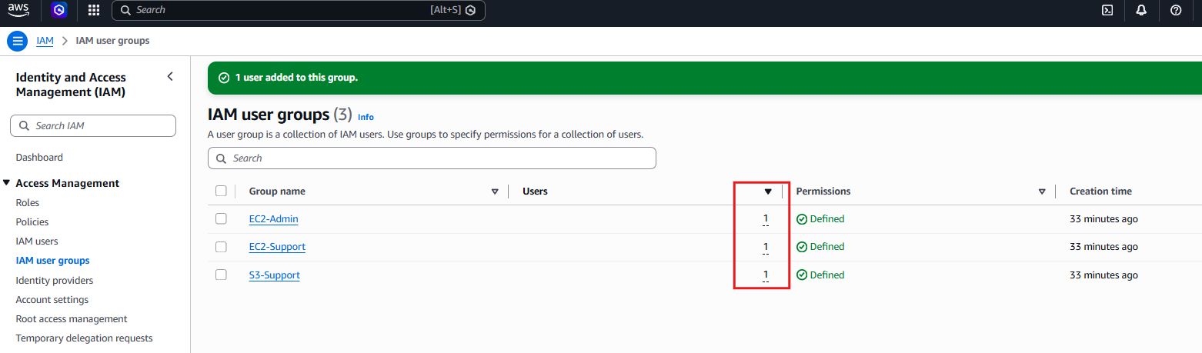
- If any group does not show 1 user, review the previous steps and ensure the following assignments are correct:
  - user-1 → S3-Support
  - user-2 → EC2-Support
  - user-3 → EC2-Admin

Task 3: Sign-In and Test Users
- In the left navigation pane, select Dashboard.
- Copy the Sign-in URL for IAM users in this account and save it in a text editor for later use.
- Open a private browsing window:
  - Chrome: New Incognito Window
  - Edge: New InPrivate Window
  - Firefox: New Private Window
  - Internet Explorer: InPrivate Browsing
Test Access as user-1 (S3 Support)
- Paste the IAM sign-in URL into the private browser and sign in using:
  - IAM user name: user-1
  - Password: Lab-Password1
- Search for and open Amazon S3.
- Open the existing S3 bucket and review its contents.
  - user-1 can view S3 buckets and objects because of the S3-Support permissions.
  - The bucket does not contain any objects.
- Search for and open Amazon EC2.
- Select Instances from the navigation pane.
  - You will receive a message stating that you are not authorized to perform this operation:
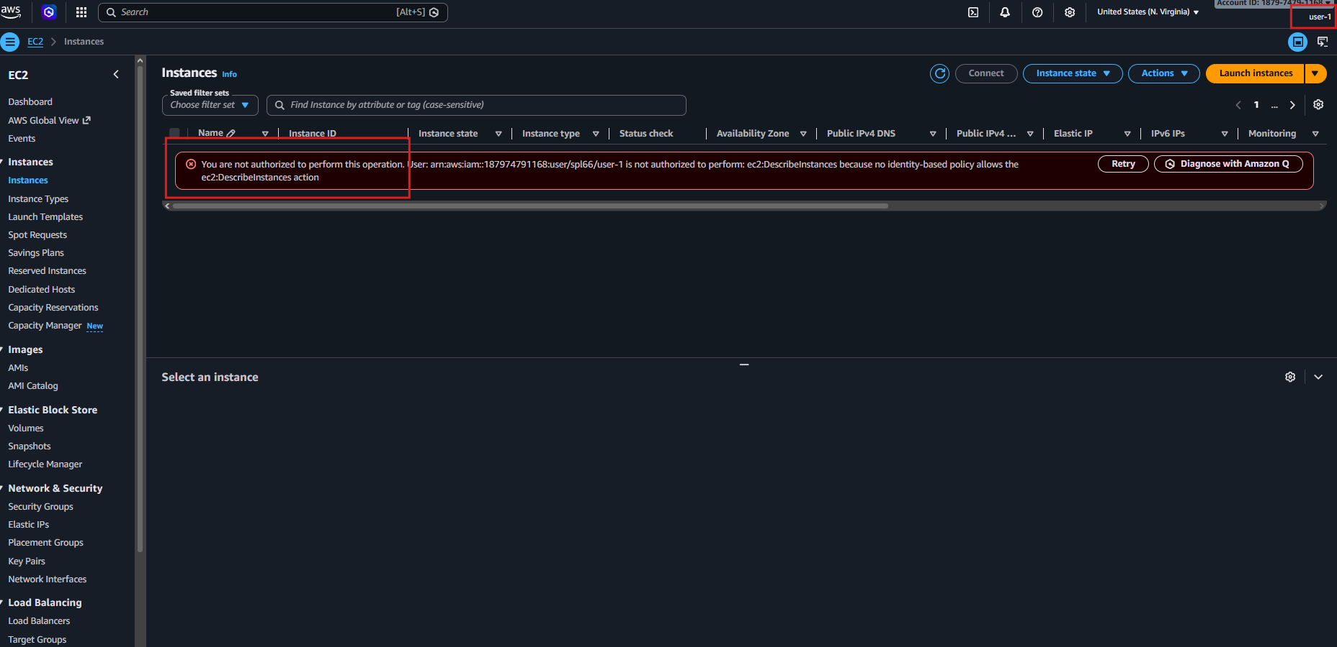
  - This confirms that user-1 does not have EC2 permissions.
Test Access as user-2 (EC2 Support)
- Sign out of the AWS Management Console.
- Return to the IAM sign-in URL and sign in using:
  - IAM user name: user-2
  - Password: Lab-Password2
- Search for and open Amazon EC2.
- Select Instances.
  - user-2 can view EC2 instances because of the EC2-Support permissions.
  - If no instance appears, verify that you are in the correct AWS Region.
- Select the LabHost instance.
- From the Instance state menu, choose Stop instance, then select Stop.
- An authorization error will appear.
  - This confirms that user-2 has read-only access and cannot make changes to EC2 resources.
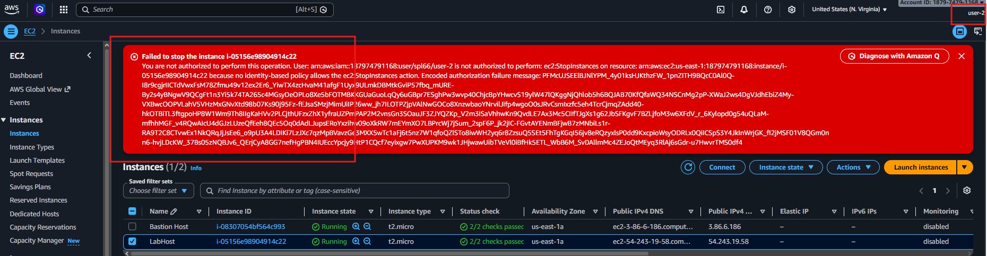
- Close the error message.
- Search for and open Amazon S3.
  - You will receive a message indicating that you do not have permission to list buckets.
  - This confirms that user-2 does not have S3 access.
Test Access as user-3 (EC2 Administrator)
- Sign out of the AWS Management Console.
- Return to the IAM sign-in URL and sign in using:
  - IAM user name: user-3
  - Password: Lab-Password3
- Search for and open Amazon EC2.
- Select Instances and locate the LabHost instance.
  - If the instance is not visible, verify that you are using the correct AWS Region.
- Select the LabHost instance.
- From the Instance state menu, choose Stop instance, then select Stop.
- The instance will successfully enter the Stopping state like below:
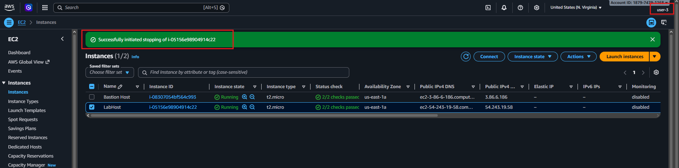
  - This confirms that user-3 has administrator permissions to manage EC2 instances.
- Close the private browser window.

Lab 2: Build your VPC and Launch a Web Server

Task 1: Create Your VPC
- In the AWS search bar, search for and open VPC.
- Verify that the selected Region is N. Virginia (us-east-1).
- From the VPC console, select VPC Dashboard, then choose Create VPC.
  - If Create VPC is not available, select Launch VPC Wizard instead.
- Configure the VPC using the following settings:
  - Resources to create: VPC and more
  - Name tag auto-generation: Auto-generate = lab
  - IPv4 CIDR block: 10.0.0.0/16
  - Availability Zones: 1
  - Public subnets: 1
  - Private subnets: 1
- Expand Customize subnets CIDR blocks and configure:
  - Public subnet CIDR: 10.0.0.0/24
  - Private subnet CIDR: 10.0.1.0/24
- Configure the remaining settings:
  - NAT gateways: In 1 AZ
  - VPC endpoints: None
  - DNS hostnames: Enabled
  - DNS resolution: Enabled
- Review the preview panel and confirm the following resources will be created:
  - VPC: lab-vpc
  - Public subnet: lab-subnet-public1-us-east-1a
  - Private subnet: lab-subnet-private1-us-east-1a
  - Route tables: lab-rtb-public and lab-rtb-private1-us-east-1a
  - Internet Gateway: lab-igw
  - NAT Gateway: lab-nat-public1-us-east-1a
- Select Create VPC.
- Wait for all resources to finish provisioning. The NAT Gateway may take several minutes to become available.
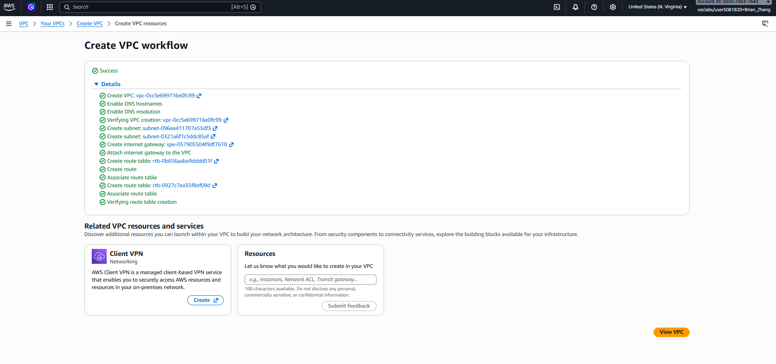
- Once deployment is complete, select View VPC.
- Review the resources created by the wizard:
  - One VPC
  - One public subnet
  - One private subnet
  - Separate route tables for each subnet
  - One Internet Gateway
  - One NAT Gateway
- Explore the VPC resources using the navigation pane. For example:
  - Select Subnets to view subnet details.
  - Select Route tables to review routing configurations.
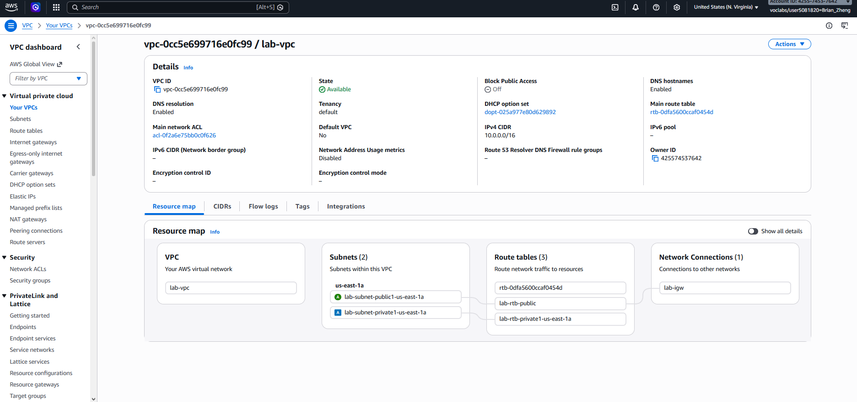
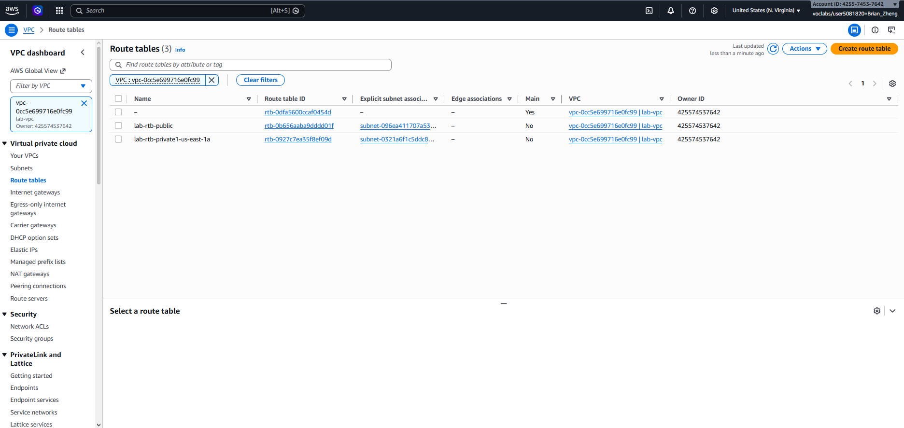
Understanding the Network Configuration:
- The Internet Gateway enables communication between resources in the VPC and the public internet.
- The public subnet (10.0.0.0/24) contains addresses in the range 10.0.0.x.
  - It is considered public because its route table sends internet-bound traffic (0.0.0.0/0) to the Internet Gateway.
- The NAT Gateway allows instances in private subnets to access the internet without being directly reachable from the internet.
- The private subnet (10.0.1.0/24) contains addresses in the range 10.0.1.x and uses the NAT Gateway for outbound internet access.

Task 2: Create Additional Subnets
- In the left navigation pane, select Subnets.
Create a Second Public Subnet:
- Choose Create subnet and configure:
  - VPC ID: lab-vpc
  - Subnet name: lab-subnet-public2
  - Availability Zone: Select the second Availability Zone (for example, us-east-1b)
  - IPv4 CIDR block: 10.0.2.0/24
- Select Create subnet.
  - This subnet will use IP addresses in the range 10.0.2.x.
Create a Second Private Subnet:
- Choose Create subnet again and configure:
  - VPC ID: lab-vpc
  - Subnet name: lab-subnet-private2
  - Availability Zone: Select the second Availability Zone (for example, us-east-1b)
  - IPv4 CIDR block: 10.0.3.0/24
- Select Create subnet.
  - This subnet will use IP addresses in the range 10.0.3.x.
It should look similar to this after these steps: 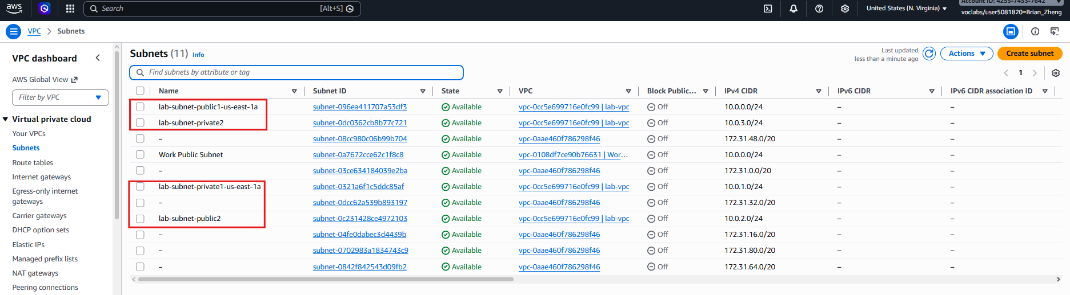
Associate the Private Route Table:
- In the left navigation pane, select Route tables.
- Select the lab-rtb-private1-us-east-1a route table.
  - If it is not visible, refresh the page.
- Open the Routes tab.
  - Notice that the destination 0.0.0.0/0 points to a NAT Gateway.
  - This allows instances in private subnets to access the internet without being publicly accessible.
- Open the Subnet associations tab.
- Select Edit subnet associations.
- Keep lab-subnet-private1-us-east-1a selected and also select lab-subnet-private2.
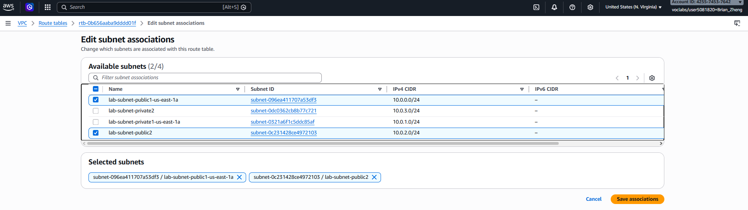
- Choose Save associations.
- Both private subnets now use the same route table and NAT Gateway.
Associate the Public Route Table:
- Select the lab-rtb-public route table.
- Open the Routes tab.
- Notice that the destination 0.0.0.0/0 points to an Internet Gateway (IGW).
- This allows resources in public subnets to communicate directly with the internet.
- Open the Subnet associations tab.
- Select Edit subnet associations.
- Keep lab-subnet-public1-us-east-1a selected and also select lab-subnet-public2.
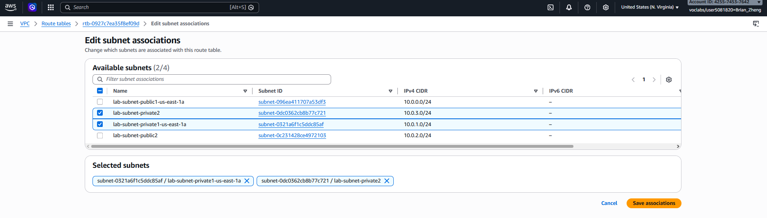
- Choose Save associations.
Result:
- Your VPC now contains:
- Two public subnets across two Availability Zones
- Two private subnets across two Availability Zones
- A public route table connected to the Internet Gateway
- A private route table connected to the NAT Gateway
- The new subnets are now configured to route network traffic correctly based on whether they are public or private.

Task 3: Create a VPC Security Group:
- In the left navigation pane, select Security groups.
- Choose Create security group and configure:
  - Security group name: Web Security Group
  - Description: Enable HTTP access
  - VPC: lab-vpc
- Under Inbound rules, select Add rule and configure:
  - Type: HTTP
  - Source: Anywhere-IPv4
  - Description: Permit web requests
After these two steps it should look like this: 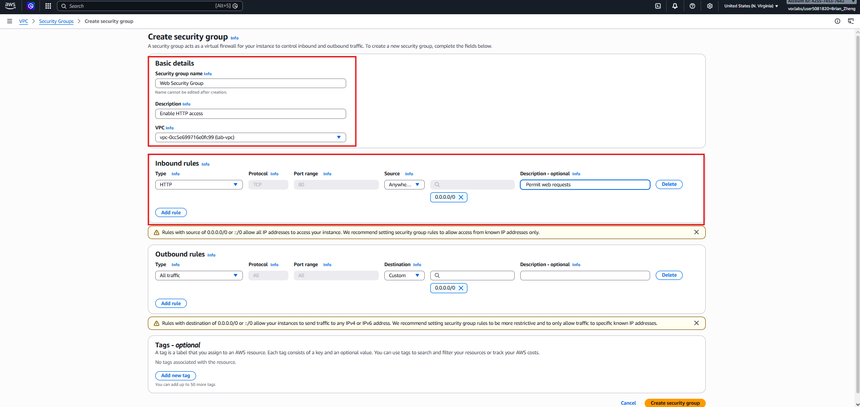
- Scroll to the bottom of the page and choose Create security group.
- The Web Security Group will be used when launching the EC2 web server.

Task 4: Launch a Web Server Instance
- Search for and open EC2 from the AWS search bar.
- Select Launch instance.
- Configure the instance:
  - Name: Web Server 1
AWS automatically creates a Name tag using this value.
- Under Application and OS Images (AMI):
  - Keep the default Amazon Linux 2023 AMI selected.
- Under Instance type:
  - Keep the default t2.micro instance type.
- Under Key pair:
  - Select vockey.
- Under Network settings, choose Edit and configure:
  - Network: lab-vpc
  - Subnet: lab-subnet-public2
  - Auto-assign public IP: Enable
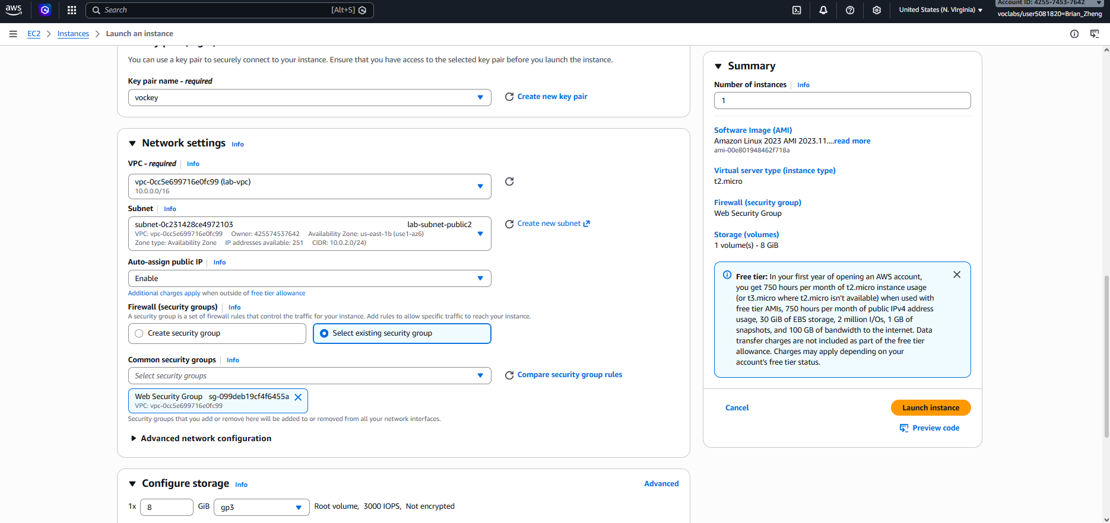
- Under Firewall (security groups):
  - Select Choose existing security group
  - Select Web Security Group
- Leave the default storage settings unchanged.
Configure User Data
- Expand Advanced details and scroll to User data.
- Paste the following script into the User data box:
#!/bin/bash
# Install Apache Web Server and PHP
dnf install -y httpd wget php mariadb105-server
# Download Lab files
wget https://aws-tc-largeobjects.s3.us-west-2.amazonaws.com/CUR-TF-100-ACCLFO-2/2-lab2-vpc/s3/lab-app.zip
unzip lab-app.zip -d /var/www/html/
# Turn on web server
chkconfig httpd on
service httpd start
- This script automatically:
  - Installs Apache, PHP, and database components
  - Downloads the lab application
  - Configures and starts the web server
- Review the settings and choose Launch instance.
- When the success message appears, select View all instances.
Verify the Web Server
- Wait until Web Server 1 displays 2/2 checks passed in the Status Check column.
  - Refresh the page periodically to monitor progress.
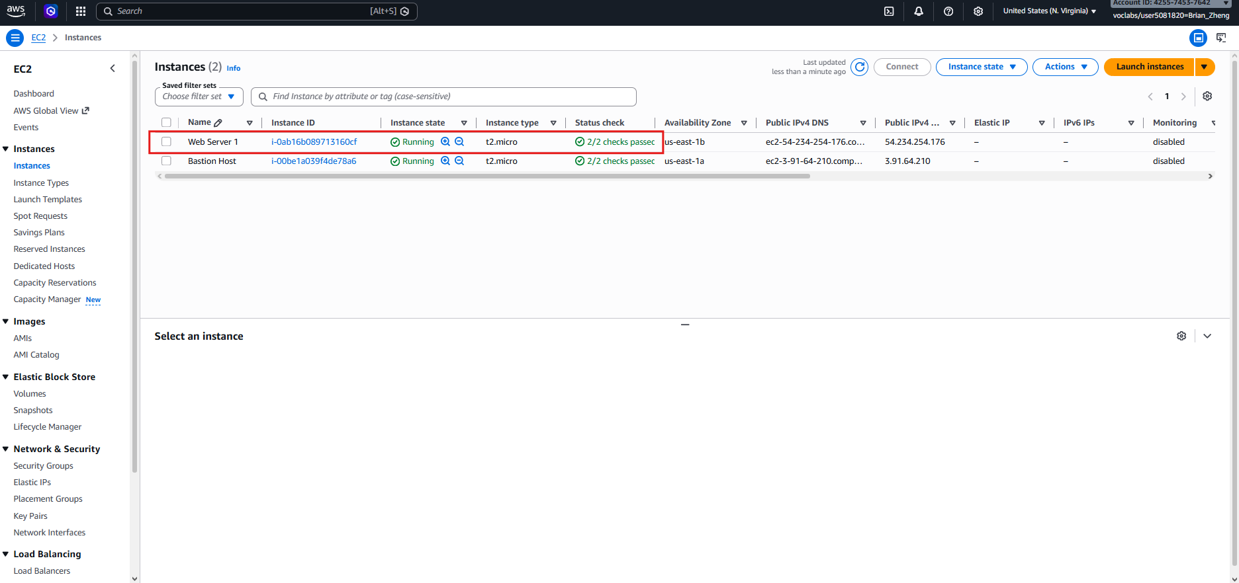
- Select Web Server 1.
- In the Details tab, copy the Public IPv4 DNS value.
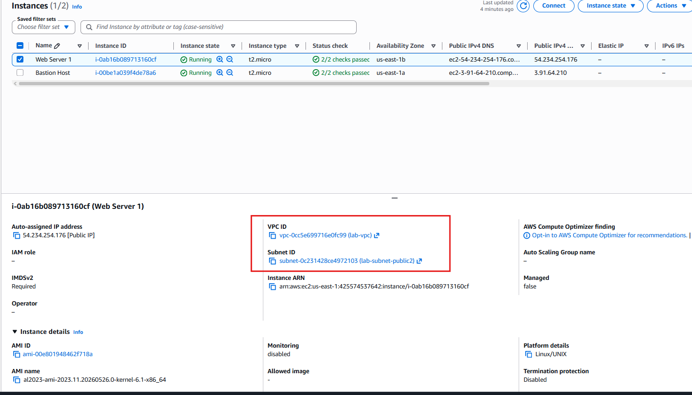
- Open a new browser tab, paste the DNS address, and press Enter.
- Verify that the web page loads successfully and displays the AWS logo along with instance metadata.
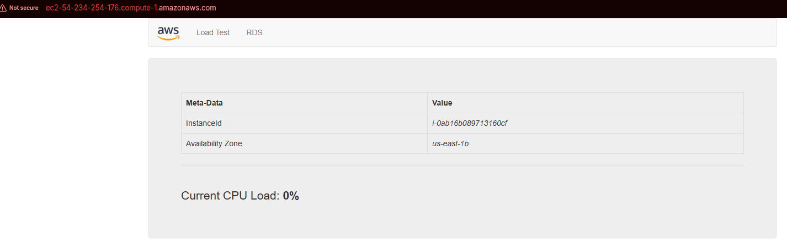
- The deployed architecture now includes:
  - A custom VPC
  - Public and private subnets across two Availability Zones
  - Internet and NAT Gateways
  - Security Groups
  - An EC2 instance hosting a web application

Lab 3: Introduction to Amazon EC2

Task 1: Launch Your Amazon EC2 Instance
Launch an Amazon EC2 Instance
- Open EC2 from the AWS Management Console.
- Verify that the selected Region is N. Virginia (us-east-1).
- Select Launch instance.
Configure the Instance
- Under Name and tags, enter:
  - Name: Web Server
AWS will automatically create a Name tag for the instance using this value.
- Under Application and OS Images (AMI):
  - Keep the default Amazon Linux 2023 AMI selected.
The AMI determines the operating system and software configuration used by the instance.
- Under Instance type:
  - Keep the default t2.micro instance type selected.
This instance type includes 1 vCPU and 1 GiB of memory.
- Under Key pair (login):
  - Select vockey.
This key pair enables secure SSH access to the instance if needed.
Configure Networking
- Under Network settings, choose Edit.
- Configure:
  - VPC: Lab VPC
  - Subnet: PublicSubnet1
  - Auto-assign public IP: Enabled
- Under Firewall (security groups):
  - Select Create security group
  - Configure:
    - Security group name: Web Server security group
    - Description: Security group for my web server
- Under Inbound security group rules, remove the default rule.
Configure Storage
- Leave the default storage settings unchanged.
  - The instance will use an 8 GiB Amazon EBS root volume.
Configure Advanced Settings
- Expand Advanced details.
- Under Termination protection, select Enable.
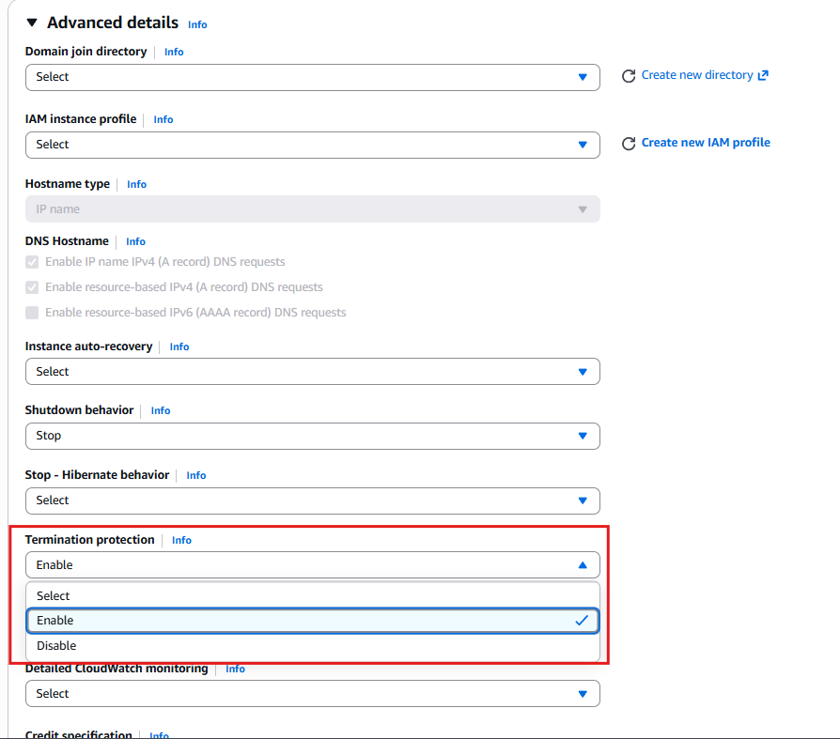
  - This prevents the instance from being accidentally terminated.
- Scroll to the User data section and paste the following script:
#!/bin/bash
dnf install -y httpd
systemctl enable httpd
systemctl start httpd
echo '<html><h1>Hello From Your Web Server!</h1></html>' > /var/www/html/index.html
- This script will:
  - Install Apache HTTP Server
  - Configure the service to start automatically
  - Start the web server
  - Create a simple web page
Launch and Verify
- Review the configuration and select Launch instance.
- When the success message appears, choose View all instances.
- Select the Web Server instance from the Instances list.
- Review the information in the Details tab, including:
  - Instance type
  - Security group settings
  - Network configuration
  - Public IPv4 DNS address
- Wait for the instance to reach the following status:
  - Instance State: Running
  - Status Checks: 2/2 checks passed
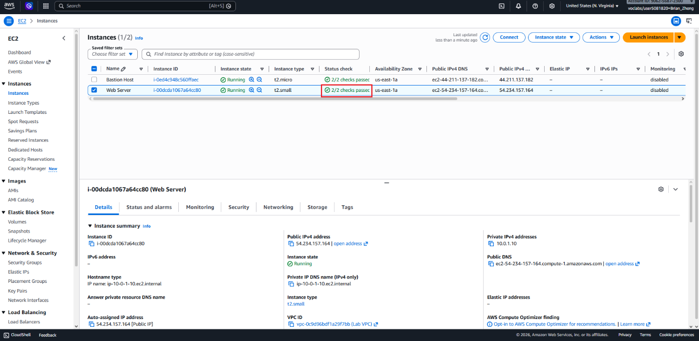
- Once these checks are complete, the EC2 instance is fully operational and ready to host the web page created by the user data script.

Task 2: Monitor Your Instance
Monitor and Troubleshoot the Instance
- Select the Status checks tab.
- Verify that both checks show Passed:
  - System reachability
  - Instance reachability
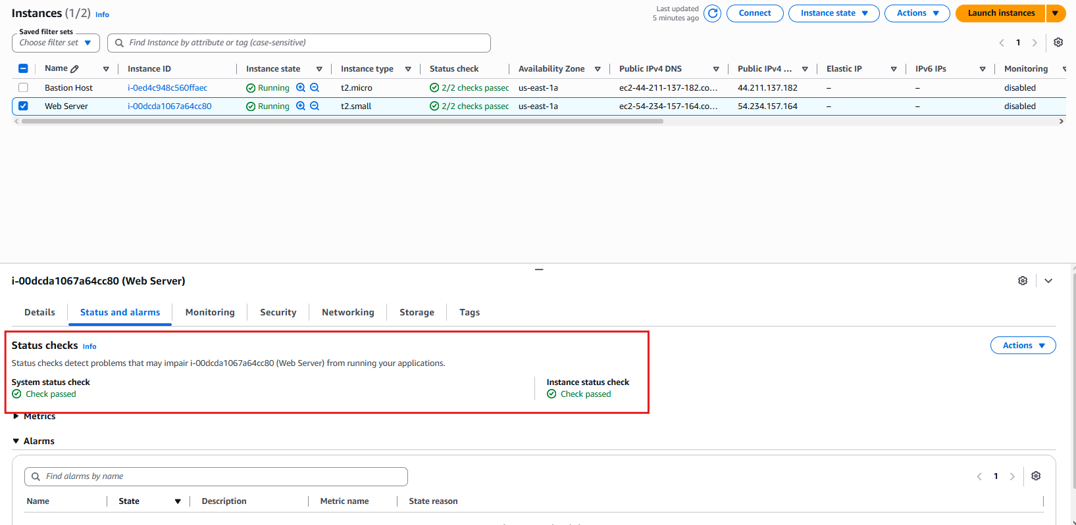
These automated checks help identify hardware or software issues that could affect instance availability.
View CloudWatch Metrics
- Open the Monitoring tab.
- Review the Amazon CloudWatch metrics for the instance.
  - Since the instance was recently launched, only a limited amount of data may be available.
  - To view a larger version of a graph, select the three-dot menu and choose Enlarge.
- By default, EC2 sends basic monitoring data to CloudWatch every five minutes. Detailed monitoring can be enabled for one-minute intervals.
View the System Log
- From the Actions menu, select:
  - Monitor and troubleshoot
  - Get system log
- Review the system log output.
  - The system log records console messages generated during startup.
  - It is useful for diagnosing boot, kernel, and service-related issues.
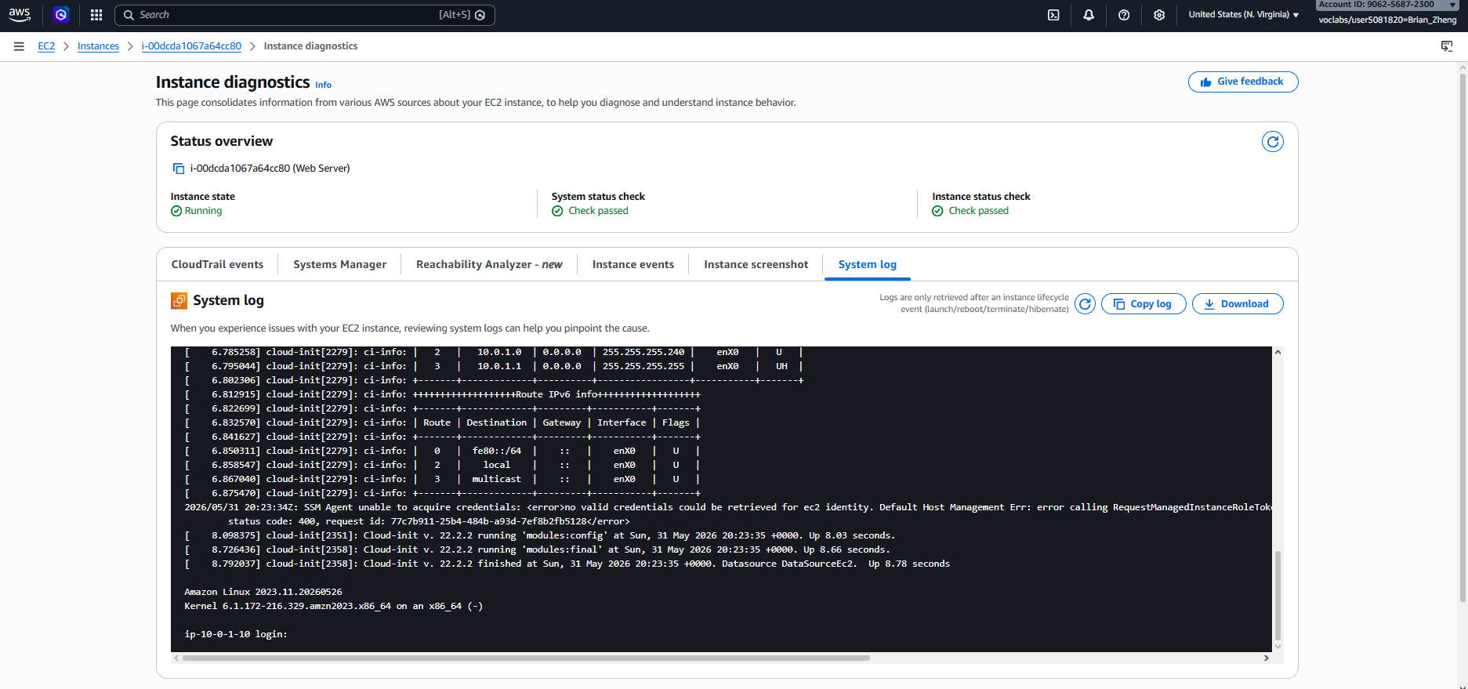
- Scroll through the log and verify that the Apache HTTP package was installed by the user data script.
- Choose Cancel to close the log window.
View an Instance Screenshot
- Ensure the Web Server instance is still selected.
- From the Actions menu, select:
  - Monitor and troubleshoot
  - Get instance screenshot
- Review the screenshot of the instance console.
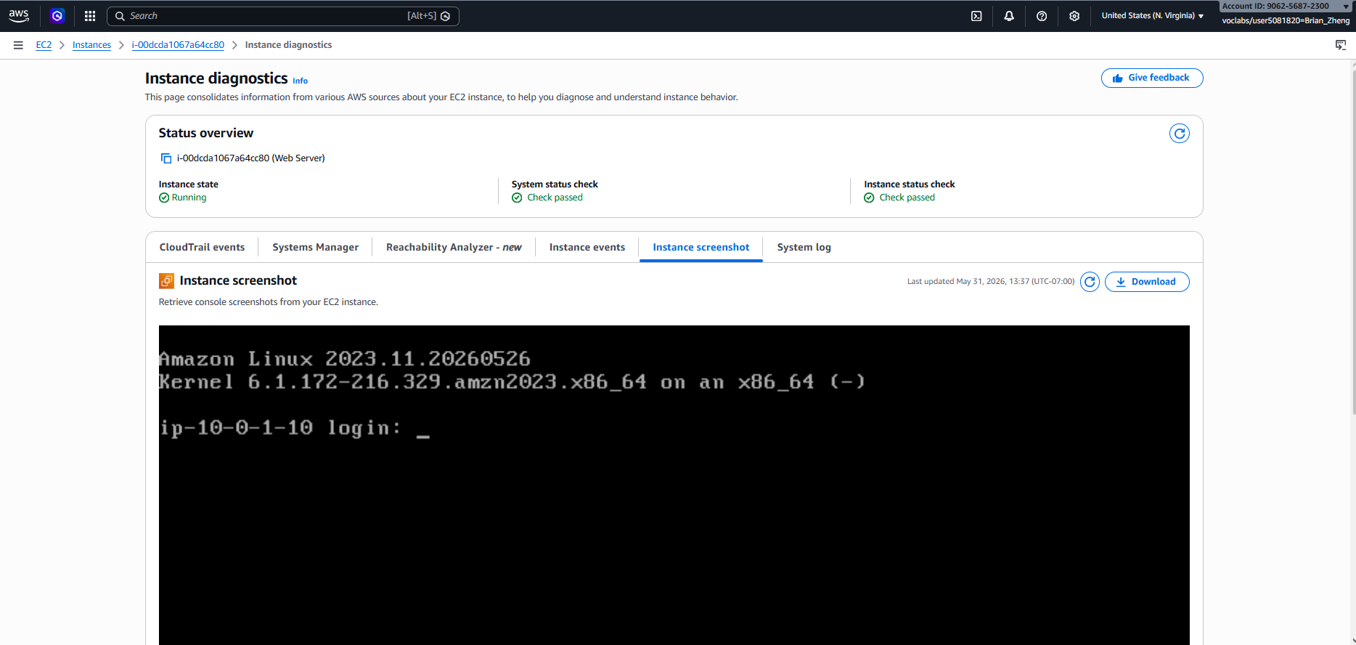
  - This displays what would appear on a monitor connected directly to the instance.
- Instance screenshots can be useful when troubleshooting systems that are unreachable through SSH or Remote Desktop.
- Choose Cancel to close the screenshot window.

Task 3: Update Your Security Group and Access the Web Server
Test Access to the Web Server
- Ensure the Web Server instance is selected and open the Details tab.
- Copy the instance's Public IPv4 address.
- Open a new browser tab, paste the IP address into the address bar, and press Enter.
- Notice that the web page does not load.
The security group currently does not allow inbound HTTP traffic on port 80 which is why web results are blocked.
Update the Security Group
- Keep the browser tab open and return to the EC2 Console.
- In the left navigation pane, select Security Groups.
- Choose Web Server security group.
- Open the Inbound rules tab.
  - Notice that there are currently no inbound rules configured.
- Select Edit inbound rules, then choose Add rule.
- Configure the rule:
  - Type: HTTP
  - Source: Anywhere-IPv4
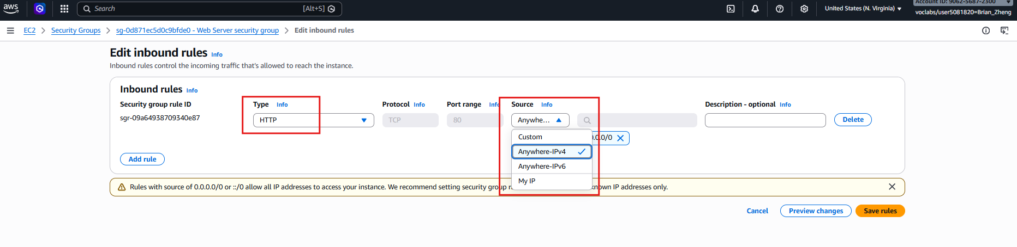
- Choose Save rules.
Verify Access
- Return to the browser tab containing the web server's IP address.
- Refresh the page.
- The web page should now load successfully and display:
Hello From Your Web Server!
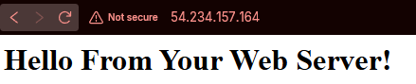

Task 4: Resize Your Instance: Instance Type and EBS Volume
Stop the Instance
- In the EC2 Console, select Instances and choose the Web Server instance.
- From the Instance state menu, select Stop instance, then choose Stop to confirm.
- Wait until the instance state changes to Stopped.
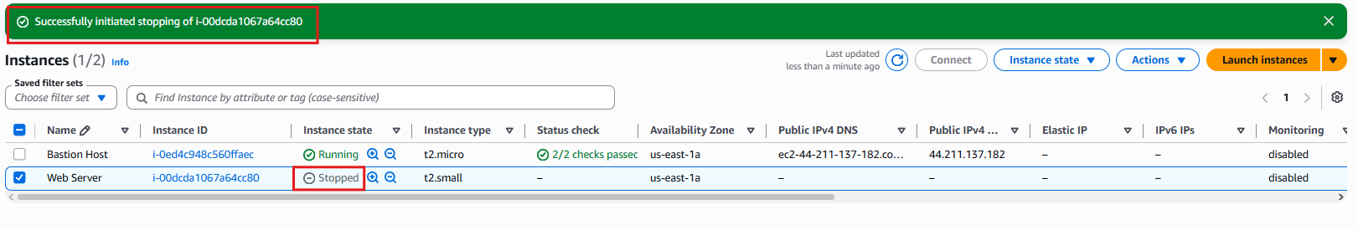
  - A stopped instance does not incur compute charges.
  - Any attached EBS volumes continue to incur storage charges.
Resize the Instance
- With the Web Server instance selected, open:
  - Actions → Instance settings → Change instance type
- Set:
  - Instance type: t2.small
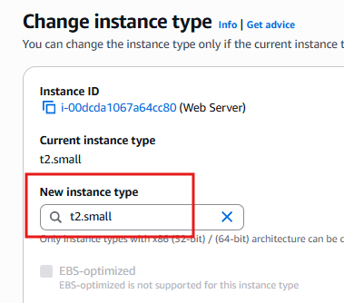
- Choose Apply.
  - The t2.small instance provides twice the memory of a t2.micro instance.
Enable Stop Protection
- Select:
  - Actions → Instance settings → Change stop protection
- Enable Stop protection and save the change.
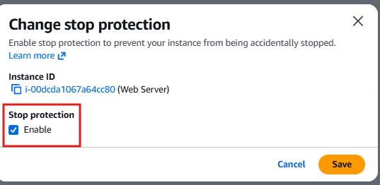
  - Stop protection helps prevent accidental shutdowns.
  - When an instance is stopped and restarted, it may receive a new public IPv4 address, but it retains its private IPv4 address and EBS volumes.
Increase the EBS Volume Size
- Open the Storage tab and select the attached Volume ID.
- Select the volume, then choose:
  - Actions → Modify volume
- Change the volume size from 8 GiB to 10 GiB.
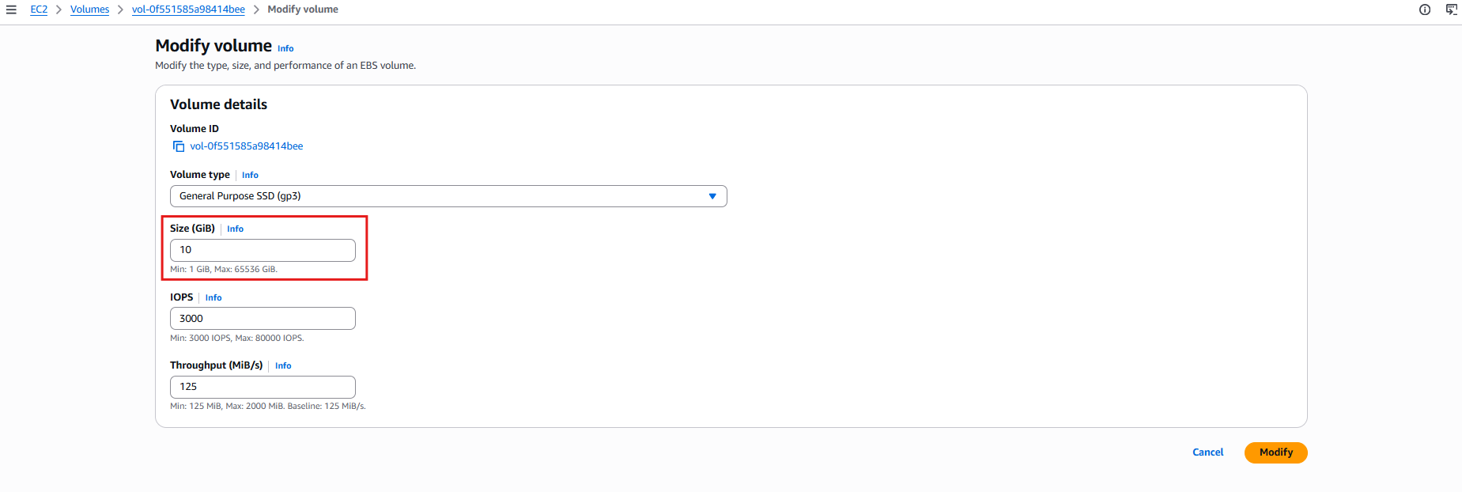
- Choose Modify, then confirm by selecting Modify again.
Start the Updated Instance
- Return to Instances.
- Select the Web Server instance.
- From the Instance state menu, choose Start instance.
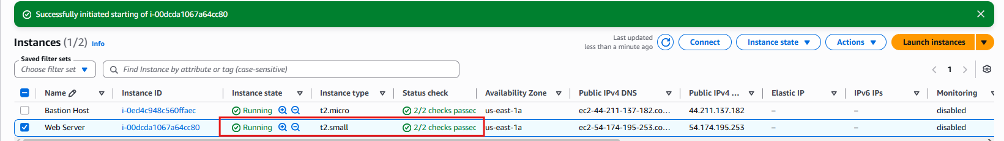
- The instance now runs with:
  - t2.small instance type
  - 10 GiB EBS root volume

Task 5: Explore EC2 Limits
- Search for and open Service Quotas.
- In the navigation pane, select AWS services.
- Search for and select Amazon Elastic Compute Cloud (Amazon EC2).
- In the Find quotas search box, enter:
  - running on-demand:
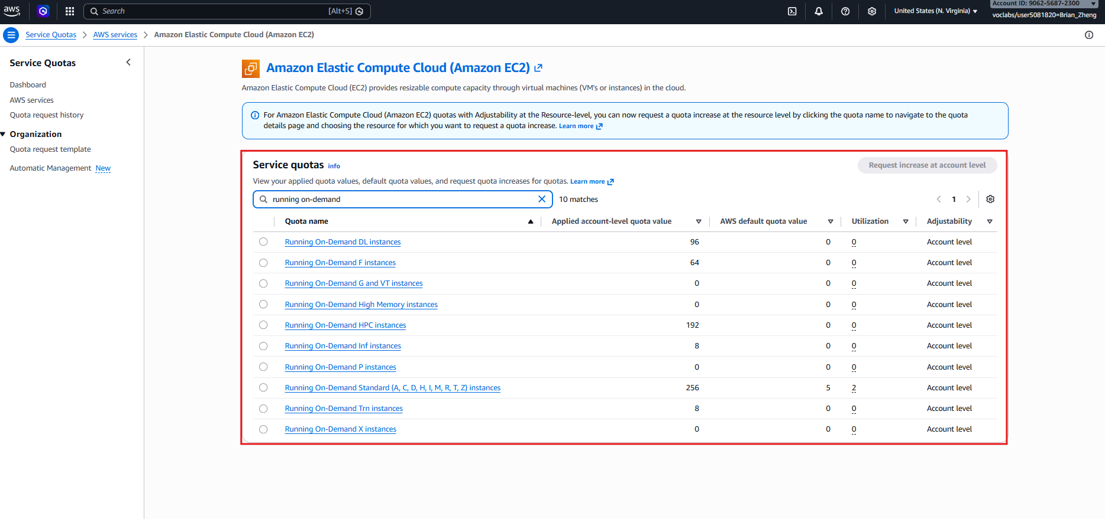
- Review the displayed quotas.
- These limits control the number and types of EC2 instances that can run within a region.
- AWS account owners can request increases for many service quotas if needed.

Task 6: Test Stop Protection
- Return to the EC2 Console and open Instances.
- Select the Web Server instance.
- From the Instance state menu, choose Stop instance, then select Stop.
- Notice the error message indicating that the instance cannot be stopped.s
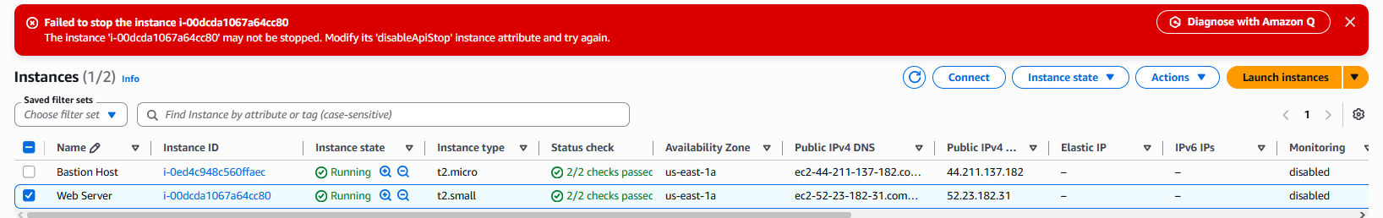
- This occurs because Stop Protection is enabled.
Disable Stop Protection
- Select:
  - Actions → Instance settings → Change stop protection
- Clear the Enable checkbox.
- Choose Save.
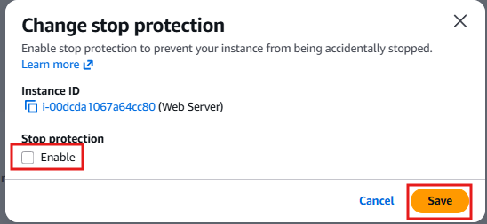
Stop the Instance
- Select the Web Server instance again.
- From the Instance state menu, choose Stop instance.
- Select Stop to confirm.
- The instance will now stop successfully because stop protection has been disabled.
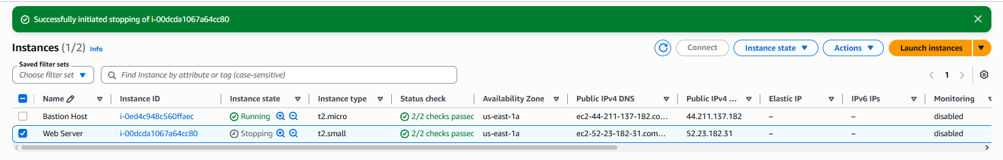

Problems
The labs were pretty straight forward, and the website was kind of easy to navigate. The only problem was that the website was kind of annoying sometimes and I had to redo a few labs due to it not detecting me doing a few of the steps.
Conclusion
In conclusion these labs were pretty interesting and are helpful for introducing people into using AWS.

